Placement Solution:

Microsoft :
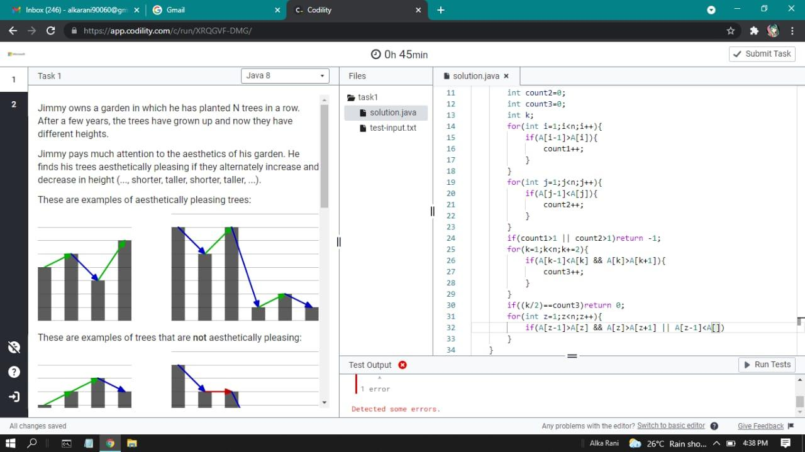
Problem Link:https://stackoverflow.com/questions/62392510/find-and-format-visually-aesthetically-pleasant-pattern-of-trees-in-a-forest-usi

Solution: https://pastebin.com/kVKLxaDZ
- //AESTHETICALLY PLEASING TREE
- #include <bits/stdc++.h>
- using namespace std;

- bool checkValid(vector<int> &arr) {
- int n = arr.size();
- if(n < 3)
- return true;

- for(int i=0; i<n-2; i++){
- int a = arr[i];
- int b = arr[i+1];
- int c = arr[i+2];
- if(a-b < 0 && b-c < 0)
- return false;
- if(a-b > 0 && b-c > 0)
- return false;
- }
- return true;
- }

- int sol(vector<int> &B) {
- if(checkValid(B))
- return 0;
- int n = B.size();
- int count=0;
- vector<int> a(n-1);
- for(int i =0; i<n; i++){
- a.clear();
- for(int j=0; j<i; j++)
- a.push_back(B[j]);

- for(int j=i+1; j<n; j++)
- a.push_back(B[j]);

- if(checkValid(a))
- count++;
- }
- return count == 0? -1 : count;
- }

- int main() {
- int n;
- cin>>n;
- vector<int> A(n);
- for (int i=0; i<n; i++) {
- cin>>A[i];
- }
- cout<<sol(A);
- }

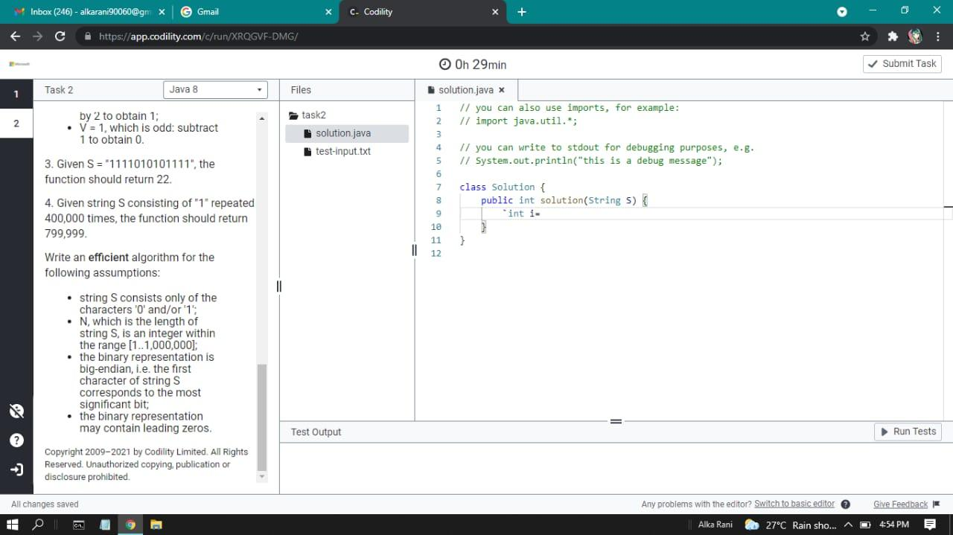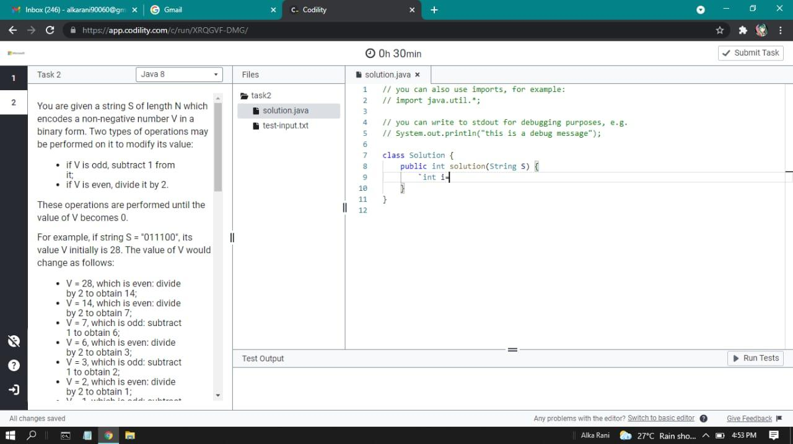
QUS-2. Binary Encodes solutions: https://pastebin.com/bpxhDtic

- //BINARY ENCODES

- #include <iostream>
- using namespace std;

- int solution(string &s) {
- int n = s.size();
- int i=0;
- for (; i<n; i++) {
- if (s[i] == '1') {
- break;
- }
- }
- int ans = 0;
- if (i == n) {
- return ans;
- }
- for (int j=n-1; j>i; j--) {
- if (s[j] == '0') {
- ans += 1;
- }
- else {
- ans += 2;
- }
- }
- ans += 1;
- return ans;
- }

- int main() {
- string s = "";
- cin>>s;
- cout<<solution(s);
- }

NIT Bhopal:

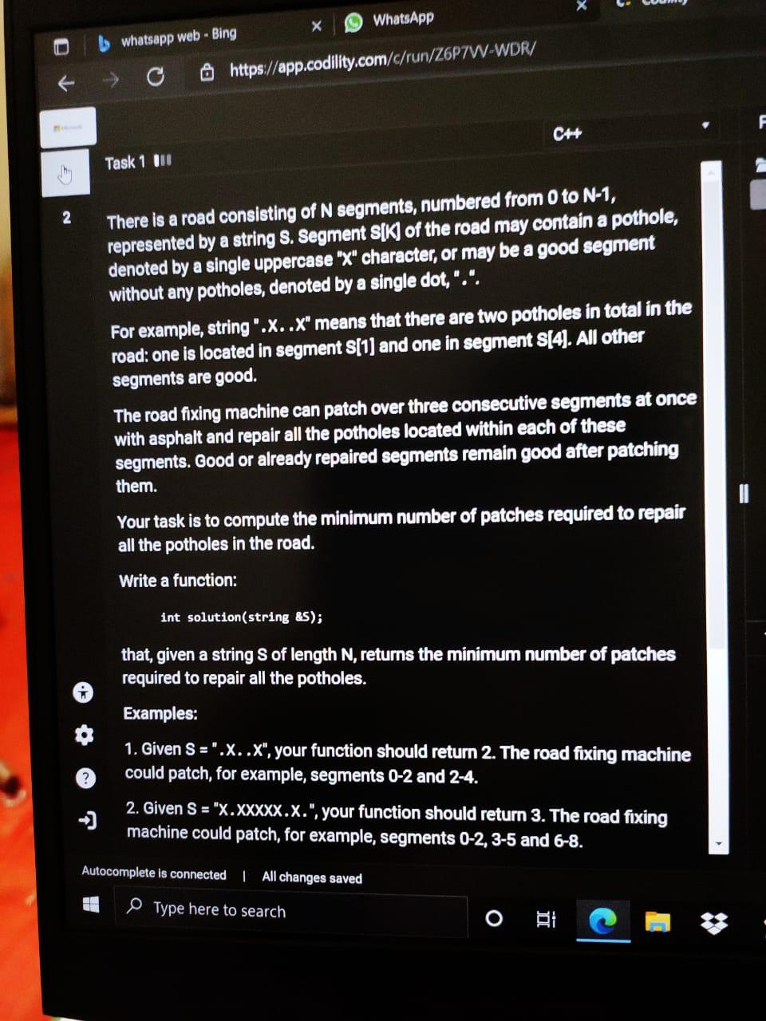
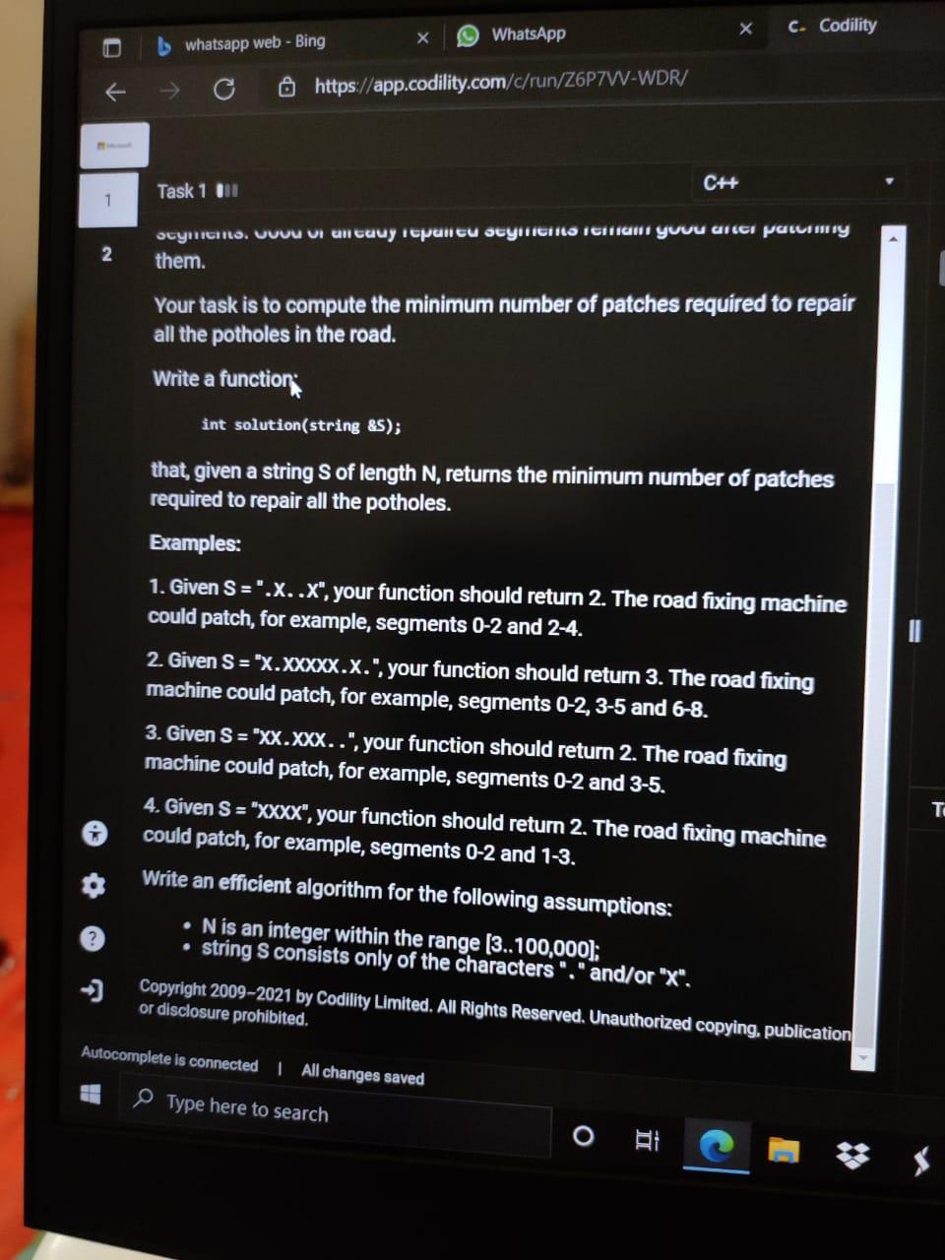

Q.1 Potholes Fixing Machine: https://leetcode.com/discuss/interview-question/1343906/microsoft-online-test-for-intern-hiring-for-2023-batch

Solution: https://pastebin.com/77kk5AMD

- #include <bits/stdc++.h>
- using namespace std;
- //POTHOLES FIXING MACHINE:
- int solution(string &s){
- int n = s.length();
- int count = 0;
- for(int i=0;i<n;i++){
- if(s[i]=='X'){
- count++;
- i=i+2;
- }
- }
- return count;
- }

- int main(){
- string s;
- cin>>s;
- cout<<solution(s);

- }

Q.2 AND BITWISE OPERATIONS : https://leetcode.com/discuss/interview-question/1345199/Microsoft-online-test-intern-hiring-2023-batch
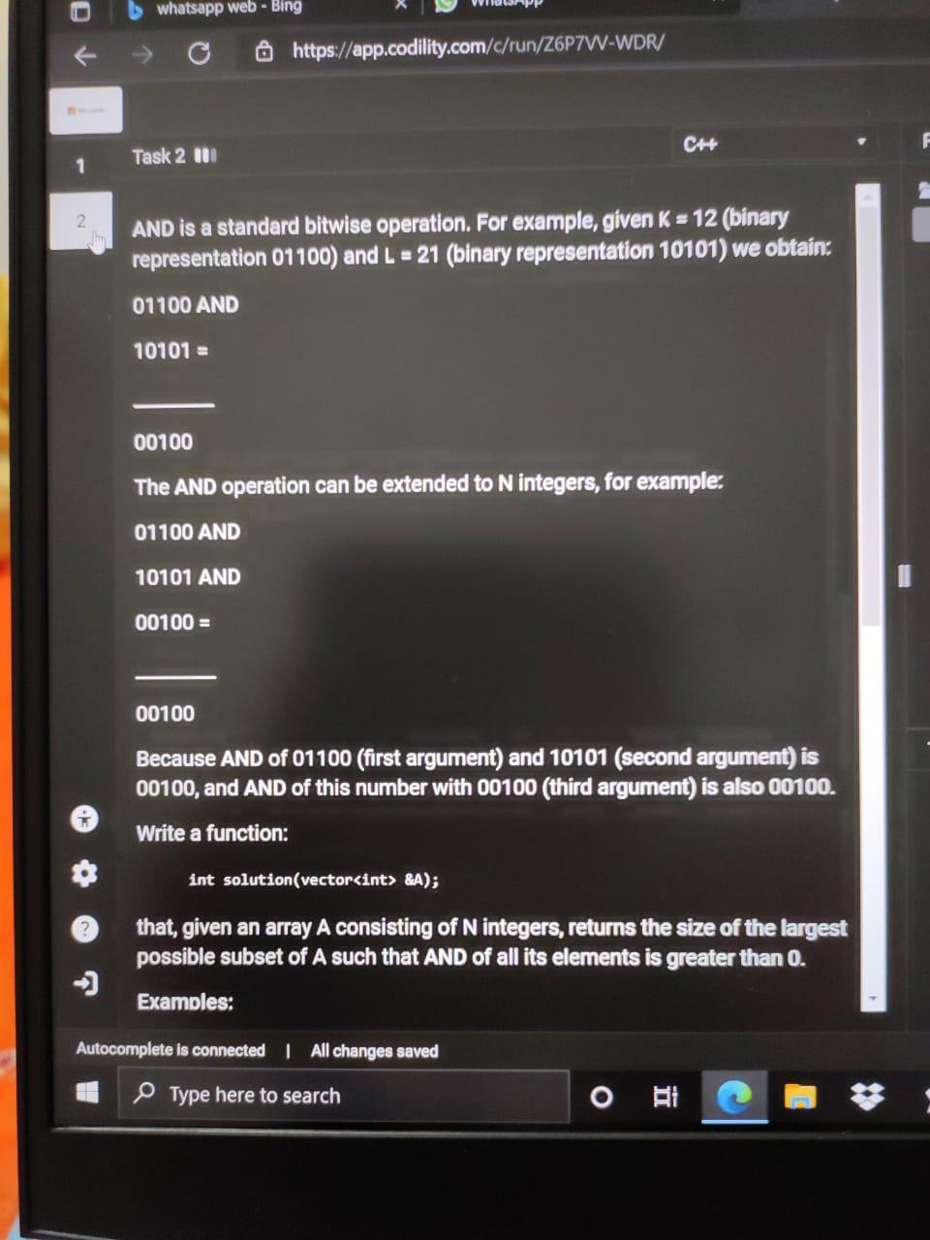
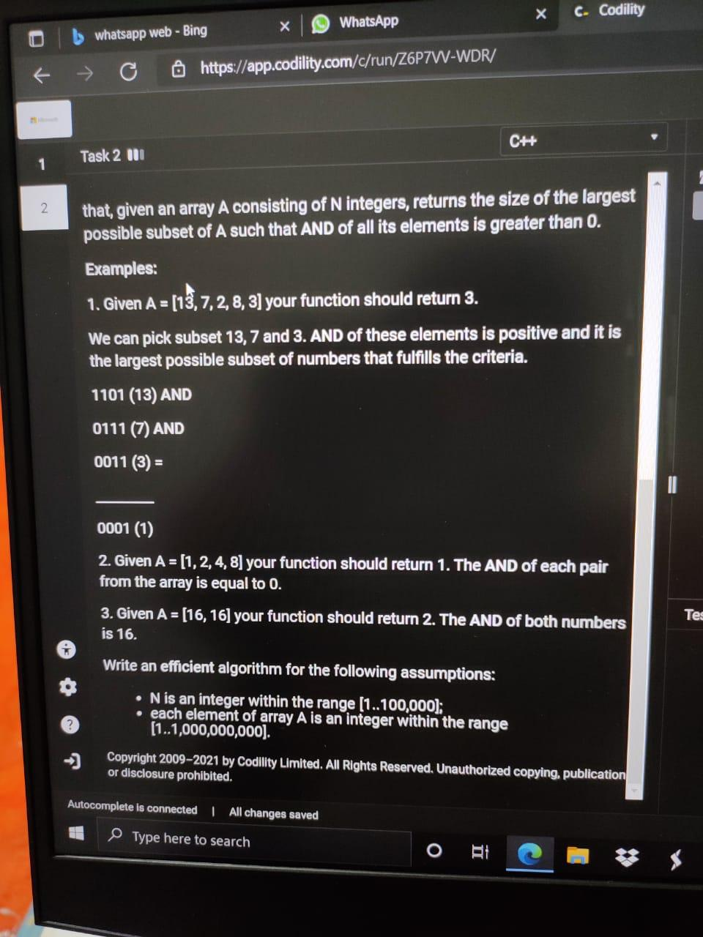

SOLUTION: https://pastebin.com/bPUyqu6m

- //AND BITWISE OPERATION:

- #include<bits/stdc++.h>
- using namespace std;

- int solve(vector<int> A){
- int count[32]={0};
- int ans = INT_MIN;
- for(int i=0; i<A.size(); i++){
- int num = A[i];
- int j=0;
- while(num>0){
- if(num%2==1)
- count[j]++;
- j++;
- num = num/2;
- }
- }
- for(int i=0; i<32; i++)
- ans = max(ans,count[i]);
- return ans;
- }

- int main() {
- vector<int> A = {16, 16};
- cout<<solve(A);
- }

